Shane Bolding

[Shb7@students.uwf.edu](mailto:Shb7@students.uwf.edu)

EEL4744L: Microprocessor Lab

Lab 5: Writing Subroutines and Using I/O Routines

10-17-19

**Objectives:**

The object of this lab is to help introduce the writing of subroutines in HC11 assembly and using the already programed BUFFALO I/O subroutines to print.

**Introduction:**

To do this lab we will be swapping the rows of a matrix in its reverse order. For this we will need to rely on the BUFFALO subroutines to print out the matrix. We also need self-made subroutines to swap the order of the rows in the matrix.

**Procedure:**

We need to write a program that prints out a matrix in its correct order using a subroutine and then it needs to switch the rows of the matrix using a subroutine. Then once that is complete print out the swapped matrix using the same subroutine that printed out the first matrix.

*Program SHB7

*Checks Array of N bytes to see if entries are +, -, even, or odd

*Declares flag counters

ORG $00

Ne RMB 1

P RMB 1

E RMB 1

O RMB 1

*Declares Array

ORG $100

N equ 5

array fcb N

*Start program

ORG $B600

ldx #array

Odd brclr 0,X,$01,Even

inc O

bra Pos

Even inc E

Pos brclr 0,X,%10000000,Neg

inc P

bra chkend

Neg inc Ne

chkend cpx #array+N-1

bhs exit

inx

bra Odd

*End Program

exit swi

Programming the code into the board and modifying the initialization of the array to have preset values we can test the array. For example, the code below.

*Program SHB7

*Checks Array of N bytes to see if entries are +, -, even, or odd

*Declares flag counters

ORG $00

Ne RMB 1

P RMB 1

E RMB 1

O RMB 1

*Declares Array

ORG $100

N equ 8

array fcb $12, $44, $31, $89, $51, $F4, $D6, $91

*Start program

ORG $B600

ldx #array

Odd brclr 0,X,$01,Even

inc O

bra Pos

Even inc E

Pos brclr 0,X,%10000000,Neg

inc P

bra chkend

Neg inc Ne

chkend cpx #array+N-1

bhs exit

inx

bra Odd

*End Program

exit swi

As you can see the array is preset. The lab is based around this array and the instructor gave us preset arrays to test. The three sets and their tests are shown below.

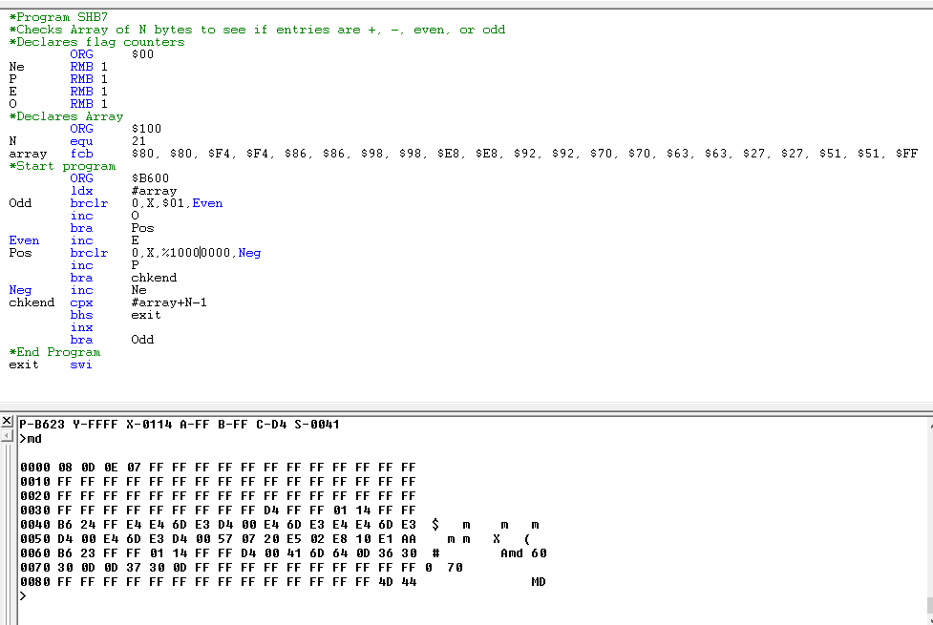

Figure The code and results above show that array N has 8 Negative #, 13 positive #, 14 even #, and 7 odd #

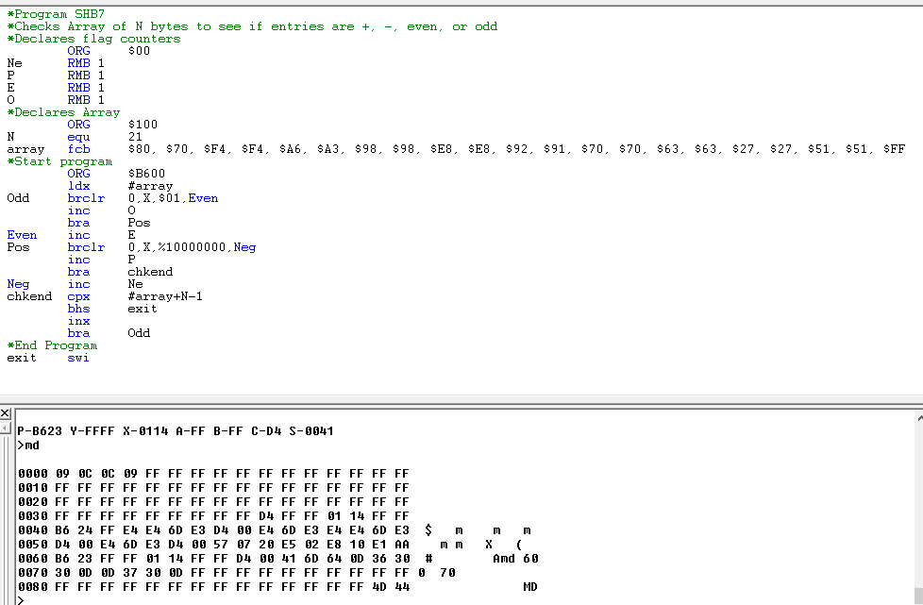

Figure The code and results above show that array N has 9 Negative #, 12 positive #, 12 even #, and 9 odd #

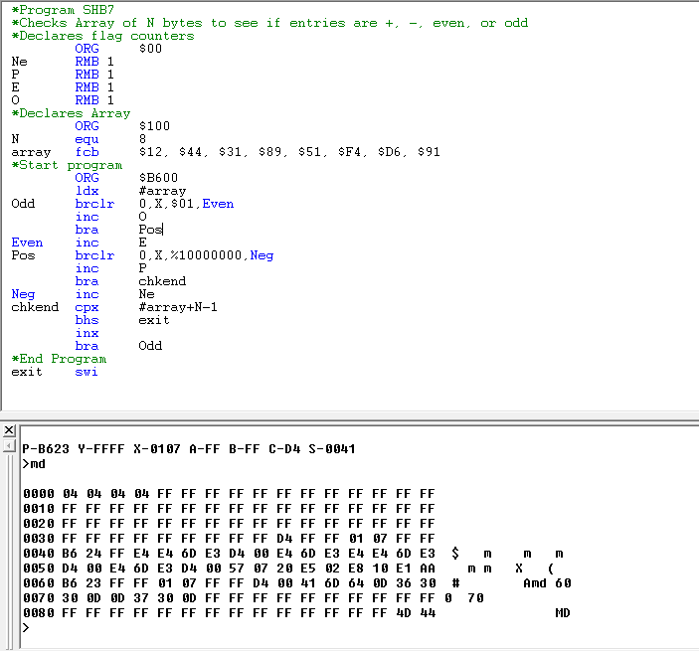

Figure The code and results above show that array N has 4 Negative #, 4 positive #, 4 even #, and 4 odd #

As you can see these pictures show the count of the even, odd, positive, and negative numbers accurately without flaw.

**Conclusion:**

This lab showed us that we can use subroutines to organize our code and declutter the main program. It also showed us that keeping up with the stack pointer, sp, is important to the running of subroutines. This is because if we mess up the sp during a subroutine we may lose our way back to the main program and possible end up in illicit memory.